COVINGTON
HIGH SCHOOL
CHARGER VOICES
HANDBOOK
Included in this handbook:
REQUIRED PARENT MEETING
August 18th @ 6:30PM
IN CHOIR ROOM
(WHICH IS BACK TO SCHOOL NIGHT)

- Information regarding choir eligibility, auditions, curriculum, fees, supplies, grading scale, classroom procedures/rules, performance attire, calendar, travel policy, etc.

- PLEASE BE SURE to fill out ALL required information and return with CHOIR $$$$ (fees)
by FRIDAY, August 14, 2015.

- Please mark ALL dates in your agenda books and keep handbook for further reference.

- please visit: www.meganallenmusic.weebly.com and www.facebook.com/chschargervoices
for further information!

Megan Allen-Director of Choirs
Covington High School
803 South College St
Covington, TN 38019
901-840-9233
mallen@tipton-county.com

Covington High School
CHARGER VOICES HANDBOOK
2015-2016

Purpose
This handbook is to provide valuable information about the vocal music program at CHS. The music program at CHS strives to achieve and maintain high standards of excellence in every aspect of music. All members and member’s caretakers should familiarize themselves with the regulations and procedures of this program.

Eligibility
The CHS CHARGER CHOIR is designed for students in 9th-12th grades. Students must display an interest in vocal music, have exemplary behavior, meet proficiency levels in achievement, and have a desire to sing in an ensemble. The success of the group as a whole is dependent upon the performance of each individual. Participation in performances is required. Absences during rehearsals must be kept to a minimum and excused by the teacher.

Auditions
Students may audition for different solo/group/events for the upcoming school year. This was done in a small group setting or individually AND in conjunction with the West TN Vocal Music Educators Association. All vocal association bi-laws MUST be followed by ALL CHS choir members. It is the sole discretion of the director whether a student should or should not be placed in the choir/solo part/groups/etc. Input regarding conduct and academics is also always accepted from teachers and school administrators.

Curriculum
The choir is the backbone of the vocal music program of CHS. The students will be assessed in a vast knowledge of proper singing techniques and repertoire ranging from classical, contemporary, jazz, swing, and sacred music. Some of the music may include choreography, and solo or small groups. We will sing accompanied and a cappella. The vast majority of musical knowledge is gained through participation in class. Students will also learn how to function as a group and develop team skills, which are vital to social development.

Performances
There will be a winter and spring program and may be blended programs with other choirs or music programs. The chorus may possibly be performing throughout the community in civic events, festivals, and recitals. Select students MAY have the opportunity to audition for the All Northwest Honor choirs, solo & ensemble contests, All State chorus and others (pending dates).
All extra-curricular performances are subject to the directors’ discretion.
(See 2015-2016 choir dates)
All choir members MUST BE PRESENT at ALL REQUIRED performances to be a member of the CHARGER VOICES.
YOUR FINAL GRADE WILL BE LOWERED FOR MISSING REQUIRED PERFORMANCES
All dates are subject to change. I will inform you as soon as I know.

Attendance/Behavior/Participation Assessment
Choir is year-round but may include short rehearsal breaks throughout the year.
The students are assessed on the following:
1/3-Rehearsal Participation-students must attend rehearsals.
Skipping is not permissible (see TCBOE Student Handbook).
In addition, they must participate during rehearsals using proper procedures and acceptable rehearsal techniques. Students will be scored according to level of participation.
1/3-Academics/Written-Professional behavior is expected from all students at all times—on or off campus. Choir students MUST keep up their classroom studies and meet proficiency levels in academic achievement. This group is a representation of the school as a whole.
Failure to comply with procedures/classroom rules may result in removal from the choir.
1/3-Performance Participation-Students will be expected to attend all performances in which their group is involved. It is IMPERATIVE that students attend ALL performances!!!! All unexcused absences will result in a 60% grade.
All dates are subject to change. I will inform you as soon as I know of any changes
(I understand that your schedule is very important).
FINAL EXAM GRADE: Winter/Spring Concert(s) will count as a portion to final exam grade as well.

CLASSROOM RULES/PROCEDURES:
- RESPECT: All choir students are expected to respect the teacher, their peers, and themselves at all times.
- SUPPLIES/EQUIPMENT: All choir students are expected to take care of all equipment, music, supplies at all times.
- ENTERING/EXITING ROOM: All choir students must enter/exit choir room in an orderly fashion. All trash, personal property, and chorus supplies MUST be returned/picked up/replaced.
- GUM/DRINKS/FOOD: NO gum, food, or drinks (besides water) are permitted during classtime. Students are NOT allowed to have lunch in the choir room (unless Mrs. Allen provides). This can pose a potential choking hazard.
- BE RESPONSIBLE, HEALTHY, YOURSELF, MATURE, & ENJOY!

Fees/Supplies
*new this year!!!!
FEES-Each member of the chorus is asked to pay $100/NEW CHOIR STUDENT AND $50/PAST STUDENT (WITH CHOIR ATTIRE)
CHOIR MEMBERS WILL BE REQUIRED TO WEAR FORMAL PERFORMANCE ATTIRE WHICH IS INCLUDED IN THE FEE.
PREVIOUS STUDENTS THAT HAVE LOST PIECES OF ATTIRE ARE RESPOSIBLE FOR REPLACEMENT COSTS.
CHOIR ATTIRE WILL BE ORDERED BY MRS. ALLEN FROM THE SCHOOL ACCOUNT.
(IF A PARENT NEEDS TO USE A CREDIT CARD TO MAKE THE PURCHASE, PLEASE SEE MRS. ALLEN)
This fee includes a choir t-shirt that will be worn on the days of CASUAL performances.
Fees will also help defray the cost of music, travel and other materials and supplies.
Fee waiver does not cover the cost of choir.
Students that do not pay choir fees will be placed on the school-wide debt list and will be unable to receive report card or diploma until paid.
Checks may be made payable to CHS.
(PLEASE INCLUDE CHOIR/CHILD’S NAME ON THE CHECK).
All fees must be paid by August 28th, 2015
Other fees may include the following: All Northwest Honor choir, QUAD STATE FEES, All State Choir fees/participation AND/OR choir trip fees.

SUPPLIES-
- CHOIR STUDENTS WILL NEED TO PROVIDE: Supplies are due by the first full day of class (which should be BEFORE receiving this pack of information:
- CHAMBER CHOIR: 2 BOXES OF TISSUE
- LADIES CHOIR: BOTTLE OF GERM-X
- CONCERT CHOIR: Men: 12 PRE-SHARPENED PENCILS Ladies: Bottle of handsoap

Performance Attire
As part of the choral fees this year, Mrs. Allen will be ordering each member formal choir attire to be worn during formal performances. Students will be measured at school during class time. STUDENTS/PARENTS May also purchase choir attire from students who graduated last year. Fit is VERY important and will need to be tailored to fit appropriately.
ALL CHOIR STUDENTS ARE RESPONSIBLE FOR THEIR ATTIRE. IF A STUDENT LOSES OR DAMAGES ANY PIECE OF THEIR ATTIRE THEN THEY ARE RESPONSIBLE FOR PURCHASING/REPLACING THOSE ITEMS.

- FORMAL Performance Attire: all skirts and tux pants will need to be hemmed. The choir will provide hemming but students are required to have attire cleaned and pressed before each choir performance.
  - Please make arrangements for these items BEFORE the winter concert/all west/all state/etc.
  - DO NOT WAIT until the last minute to prepare your items.
  - In addition to performance attire ladies will be asked to wear SOLID BLACK closed-toed ballet flats/slip ons shoes and a
  - Ladies: pearl necklace and/or pearl earrings.
  - Men will be required to have CLEAN SOLID BLACK dress shoes will BLACK LACES AND BLACK BOTTOMS, AND A SOLID BLACK BELT.
  - If you are chosen for the All Northwest Honor Choir or All-State Choir, you will wear this attire

- CASUAL ATTIRE: CHOIR T-SHIRTS WILL BE WORN FOR PERFORMANCES SUCH AS:
  - PEP RALLY PERFORMANCES/FOOTBALL GAMES/CASUAL PERFORMANCES choir students may wear jeans. I will notify students of dress code for each particular performance.
  - NO SANDALS OR FLIP FLOPS, BIG HAIRBOWS, or BIG BELTS PLEASE!!!
  - SMALL SILVER OR GOLD EARRINGS AND/OR A SMALL NECKLACE MAY BE WORN.

If you are chosen for the All Northwest Honor Choir or All-State Choir, you will have a separate dress code to follow.

Fundraising
There will be a few opportunities during the school year for students to raise money for the vocal music program.
Donations are also gladly accepted. CHOIR PARENT BOOSTER will be making other arrangements for fundraising as well.
Mrs. Allen and the CHOIR PARENTS will HELP direct all fundraising.

Travel Policy
In the event that the CHS CHARGER choir/individuals will travel to any events away from the school throughout the school year, we will represent not only the vocal music program, but the school as a whole. Undignified conduct or reckless behavior may result in dismissal from the group, parent phone call, and/or disciplinary action from the CHS administration or TCBOE. (See TCBOE student handbook for further information)
This is a PRIVILEGED CHOIR!
Let’s all take responsibility to work together to make yourselves and the group the best it can be! Academic achievement, behavior/conduct, character, and musical/singing abilities will all be accounted for!

CONTACTS
YOU MAY CONTACT Mrs. Allen ANY TIME AT SCHOOL @ 840-9233.
If you need to schedule a meeting during my planning time, DO NOT HESITATE TO CALL.
You may also email me: mallen@tipton-county.com
ALL OTHER INFORMATION REGARDING MAPS, LINKS, ALL-WEST AUDITIONS, CALENDAR, ETC CAN BE FOUND AT:
www.meganallenmusic.weebly.com
www.facebook.com/chschargervoices

2015-2016
CHS CHARGER VOICES CALENDAR

August (Other tentative PERFORMANCES: ? )
14 F Choir fees and contracts Due
18 Th Required Choir Parent meeting @ 6:30pm in the choir room
20 Th Thornton’s Pool Party (pending board approval)
28 F Home Football game (National Anthem small group)

September (Other tentative PERFORMANCES: homecoming, FB games, CES grandparents day)
1 M No school-Labor day
11 F Home Football game (National Anthem-group TBA)
17 TH TIPTON COUNTY HIGH SCHOOL ALL WEST CONCERT (TIME AND LOCATION TBA)
26 SA All Northwest SR. HIGH Honor Choir Auditions-Union University, Jackson, TN

October (Other tentative PERFORMANCES: TBA)
1/2 TH/F HOMECOMING TALENT SHOW AUDITIONS
7 W PURPLE AND GOLD IDOL (1:00PM IN GYM)
9 F HOMECOMING football game NATIONAL ANTHEM performance (SELECT CHOIRS)
12-16 M-F Fall Break (No School)
23 F HOME football game performance—(NATIONAL ANTHEM SELECT SMALL GROUP)
24 Sat ALL Northwest JR. HIGH Choir Auditions in Jackson, TN (UNIVERSITY SCHOOL-JACKSON)
30 F POSSIBLE FOOTBALL GAME NATIONAL ANTHEM PERFORMANCE (SELECT CHOIRS)

November
1-2 F-SU QUAD STATE CHORAL FESTIVAL (FOR SELECTED PARTICIPANTS ONLY) MURRAY STATE UNIVERSIT
5 Th REQUIRED ALL WEST PARTICPANTS ONLY REHEARSAL 3:00-5:00pm
5 T REQUIRED PARENT MEETING FOR ALL WEST PARTCIPANTS ONLY 5:00-6:00pm
11 T VETERAN’S DAY (POSSIBLE PERFORMANCE)
19-21 TH-SAT All Northwest Honor Choir in Jackson, TN
23-27 M-F Thanksgiving Break (No School)

December (OTHER CHRISTMAS PERFORMANCES MAY BE ADDED)
5 SA ALL STATE AUDITIONS
10 TH COMBINED CHS CHOIR/BAND AND CMS MUSIC Winter Concert @ 7:00 (location TBA)
18 TH ½ DAY OF SCHOOL
21-1 M-F Christmas Break (no school)

January (more TBA)GRIZZLIES GAME?
18 M MLK Day (No School)
30 Sat All State Octet Testing-COLONIAL MIDDLE SCHOOL (All State STUDENTS ONLY)

February (more TBA)
15 M President’s Day (No School)
18 TH Solo and Ensemble Contest-UNIVERSITY OF MEMPHIS(ADVANCED CHOIR participants TBA)

March (more TBA)
4 F SENIOR HIGH CHORAL FESTIVAL
11 F TIPTON’S GOT TALENT-CHS GYM (CHS CHOIR SPONSORED) TIMES TBA
21-25 M-F Spring Break (No School)
31 TH JACKSON CHORAL FESTIVAL

April (more TBA)
11 M REQUIRED PARENT MEETING FOR ALL STATE PARTICIPANTS 5:30 IN CHOIR ROOM
13-16 W-Sat All State Music Convention (Opryland hotel-Nashville, TN)

May (more TBA)
5 Th FORMAL SPRING CONCERT
22 Sun CHS Baccalaureate
23 M CHS Graduation
27-JUNE 1 NEW YORK TRIP (ATTENDEES ARE TBA)

PLEASE REMEMBER THAT ALL DATES ARE TENTATIVE

LADIES CHOIR
2015-2016
CHS CHARGER CHOIR CONTRACT
PLEASE SIGN AND RETURN THIS PAGE TO Mrs. Megan Allen.
Failure to return this form may prevent participation in the vocal music program.

Student Name:_________________________________Student Cell:_____________________________

Can you receive a Text? YES NO

Homeroom Teacher:________________________________Grade: FR SO JR SR

STUDENT EMAIL ADDRESS:_________________________________@______________________

CHOIR PERIOD (circle): 1A 3A
Please fill out schedule on back of form

T-SHIRT SIZE (circle one): AS AM AL AXL AXXL

This shirt is covered by $100 choir dues(NEW STUDENTS) $50 (Previous students) and is required to be worn for all performances.
Students will not receive a shirt unless dues are paid. Fee Waiver does not cover choir.
(Contact Mrs. Allen for details)
Parent(s)/CaregiverName(s):_______________________________________________

PARENT EMAIL ADDRESS:_________________________________@______________________

Mailing ADDRESS:________________________________________________________

CITY:____________________________________ZIP:____________________________

PARENT HOME PHONE: (_______)________________________________________________

PARENT(S)/GUARDIAN CELL PHONE: (_______)____________________________

CAN PARENT RECEIVE A TEXT?: YES NO

WORK PHONE(S): (_______)_______________________EXT.__________________________

EMERGENCY NAME:_____________________________________
RELATIONSHIP TO STUDENT:______________________________
EMER. PHONE: ( )_________________________________
Medical Release

ALLERGIES:_____________________________________________________________
Daily MEDICATIONS:_____________________________________________________
OTHER MEDICAL CONDITIONS:____________________________________________
OTHER:_______________________________________________________________

I HAVE READ AND UNDERSTAND WHAT IS REQUIRED OF ME AS A MEMBER OF THE CHOIR PROGRAM OF COVINGTON HIGH SCHOOL. I AGREE TO ABIDE BY ALL THE REGULATIONS STATED IN THIS HANDBOOK.

*I ALSO UNDERSTAND THAT IT IS MY SON/DAUGHTER’S RESPONSIBILITY TO KEEP TRACK OF ALL FORMAL ATTIRE AND CHOIR T-SHIRT. I UNDERSTAND THAT IF THESE ITEMS ARE LOST THEN IT IS MY RESPONSIBILITY
TO REPLACE THOSE ITEMS.

I ALSO AGREE TO ALLOW MY CHILD TO GO ON FIELD TRIPS /PERFORMANCE OPPORTUNITIES LOCATED IN TIPTON COUNTY.

SIGNED_______________________________________________________
PARENT/GUARDIAN DATE

SIGNED_______________________________________________________
STUDENT DATE

*Students will be measured during school hours for formal attire
LADIES CHOIR

CHS CHARGER CHOIR STUDENT INFO

STUDENT NAME:________________________________

STUDENT SCHEDULE:

HOMEROOM:_________________________________________

1st Semester
CLASS/TEACHER’S NAME _____CLASS/TEACHER’S NAME

1ST -A DAY:___________________________B DAY___________________________

2ND -A DAY:__________________________B DAY___________________________

3RD-A DAY:__________________________B DAY___________________________

4TH-A DAY:__________________________B DAY___________________________

OTHER EXTRA ACTIVITIES/: (sports, cheer, band, etc)
______________________________________________________________________________
WHEN ARE THESE ACTIVITIES HELD?
_____________________________________________________________________________
ANY OTHER INFO THAT MRS. ALLEN MAY NEED TO KNOW?
____________________________________________________________________________________________________________________________________________________________
DO NOT WRITE BELOW THIS LINE
CONDUCT/PARTICIPATION RECORD:
PERFORMANCE(S) ATTENDED/MISSED:
MISSED REHEARSALS:
Students will be measured during school hours for formal attire
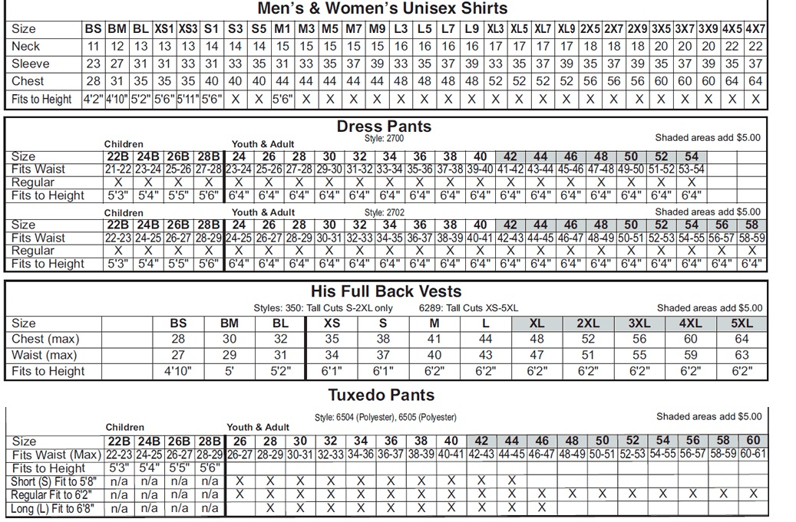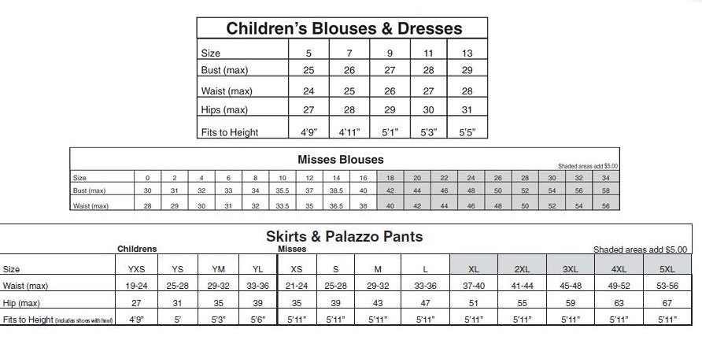

ADVANCED CHOIR
2015-2016
CHS CHARGER CHOIR CONTRACT
PLEASE SIGN AND RETURN THIS PAGE TO Mrs. Megan Allen.
Failure to return this form may prevent participation in the vocal music program.

Student Name:_________________________________Student Cell:_____________________________

Can you receive a Text? YES NO

Homeroom Teacher:________________________________Grade: FR SO JR SR

STUDENT EMAIL ADDRESS:_________________________________@______________________

CHOIR PERIOD (circle): 1A 3A
Please fill out schedule on back of form

T-SHIRT SIZE (circle one): AS AM AL AXL AXXL

This shirt is covered by $100 choir dues(NEW STUDENTS) $50 (Previous students) and is required to be worn for all performances.
Students will not receive a shirt unless dues are paid. Fee Waiver does not cover choir.
(Contact Mrs. Allen for details)
Parent(s)/CaregiverName(s):_______________________________________________

PARENT EMAIL ADDRESS:_________________________________@______________________

Mailing ADDRESS:________________________________________________________

CITY:____________________________________ZIP:____________________________

PARENT HOME PHONE: (_______)________________________________________________

PARENT(S)/GUARDIAN CELL PHONE: (_______)____________________________

CAN PARENT RECEIVE A TEXT?: YES NO

WORK PHONE(S): (_______)_______________________EXT.__________________________

EMERGENCY NAME:_____________________________________
RELATIONSHIP TO STUDENT:______________________________
EMER. PHONE: ( )_________________________________
Medical Release

ALLERGIES:_____________________________________________________________
Daily MEDICATIONS:_____________________________________________________
OTHER MEDICAL CONDITIONS:____________________________________________
OTHER:_______________________________________________________________

I HAVE READ AND UNDERSTAND WHAT IS REQUIRED OF ME AS A MEMBER OF THE CHOIR PROGRAM OF COVINGTON HIGH SCHOOL. I AGREE TO ABIDE BY ALL THE REGULATIONS STATED IN THIS HANDBOOK.

*I ALSO UNDERSTAND THAT IT IS MY SON/DAUGHTER’S RESPONSIBILITY TO KEEP TRACK OF ALL FORMAL ATTIRE AND CHOIR T-SHIRT. I UNDERSTAND THAT IF THESE ITEMS ARE LOST THEN IT IS MY RESPONSIBILITY
TO REPLACE THOSE ITEMS.

I ALSO AGREE TO ALLOW MY CHILD TO GO ON FIELD TRIPS /PERFORMANCE OPPORTUNITIES LOCATED IN TIPTON COUNTY.

SIGNED_______________________________________________________
PARENT/GUARDIAN DATE

SIGNED_______________________________________________________
STUDENT DATE
*Students will be measured during school hours for formal attire
ADVANCED CHOIR

CHS CHARGER CHOIR STUDENT INFO

STUDENT NAME:________________________________

STUDENT SCHEDULE:

HOMEROOM:_________________________________________

1st Semester
CLASS/TEACHER’S NAME _____CLASS/TEACHER’S NAME

1ST -A DAY:___________________________B DAY___________________________

2ND -A DAY:__________________________B DAY___________________________

3RD-A DAY:__________________________B DAY___________________________

4TH-A DAY:__________________________B DAY___________________________

OTHER EXTRA ACTIVITIES/: (sports, cheer, band, etc)
______________________________________________________________________________
WHEN ARE THESE ACTIVITIES HELD?
_____________________________________________________________________________
ANY OTHER INFO THAT MRS. ALLEN MAY NEED TO KNOW?
____________________________________________________________________________________________________________________________________________________________
DO NOT WRITE BELOW THIS LINE
CONDUCT/PARTICIPATION RECORD:
PERFORMANCE(S) ATTENDED/MISSED:
MISSED REHEARSALS:
Students will be measured during school hours for formal attire

